BoriMami December Specials 2019
Orders Must in by Sunday Dec 22, 2019 at 3pm and all orders picked up by Tuesday Dec 24, 2019 9am– 3pm, Please call 321-216-1378 to order or visit out store! Call if you have any questions.
Pies
Pies Ordered not from list will be $ 35.00 and Add Lattice Cover to any Pie $ 5.00
- Chocolate Silk $ 25.00
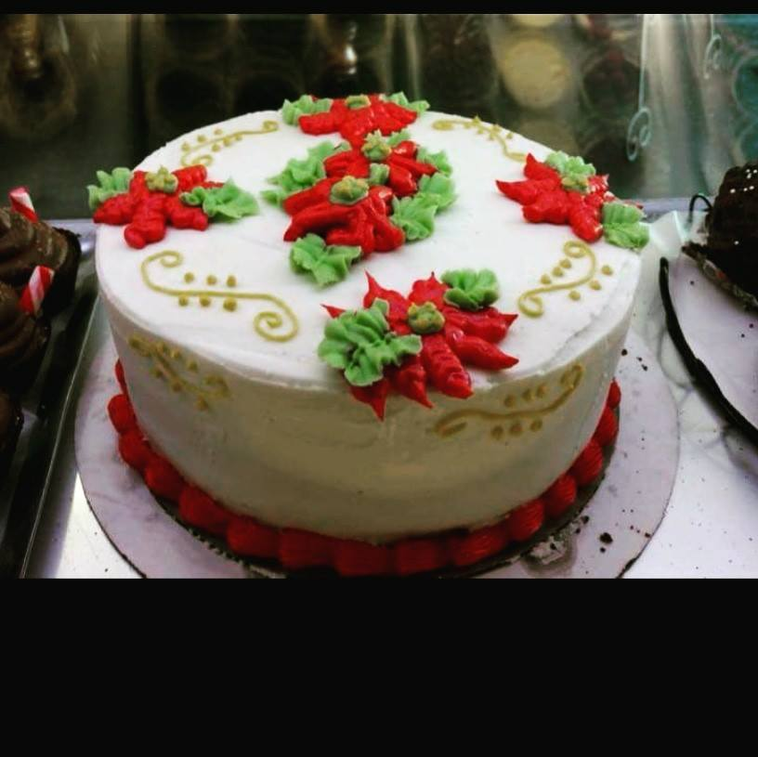
- Banana Cream Pie $ 30.00
- Apple Pie $ 25.00
- Pecan Pie $ 30.00
- Coconut Custard $ 30.00
Specialty Cakes
- Cake Log $ 30.00
- Brownie Cookie Dough Cake 9 inch $ 50.00
- Chocolate Cannoli Cake 9 inch $ 50.0
- Christmas Morning Bakery Box = 4 Scones, 4 Cheese Danish, 4 Muffins $ 36.00
Cookie Trays
Have your Cookies in a Specialty Christmas Theme Box on any order of 5 dozen or less for 5
Flavors for December: Chocolate Chip, Coconut Macaroon, Snickerdoodle, Red Velvet, Moose Tracks, Decorated Sugar Cookie, Snowball Cookie
- 1 Dozen Tray $17.00
- 2 Dozen Tray $ 29.00
- 3 Dozen Tray $ 38.00
- 4 Dozen Tray $ 50.00
- 5 Dozen Tray $ 65.00
- 10 Dozen Tray $ 110.00

BoriMami December Specials 2019 Bulk Ordering
Delivery starting at $25.00 base plus mileage and time depending on location.
Pies
- Chocolate Silk
- Banana Cream Pie
- Apple Pie
- Pecan Pie
- Coconut Custard
- Chocolate Bourbon Pecan
Pies Ordered not from list will be $ 35.00 and Add Lattice Cover to any Pie $ 5.00
Discounts for bulk order:
For 10-15 Pies $28.00 per pie
For 16-24 Pies $23.00 per pie
For 25-30 Pies $18.00 per pie

Cookie Trays
Have your Cookies in a Specialty Christmas Theme Box on any order of 5 dozen or more for 5
Flavors for December: Chocolate Chip, Coconut Macaroon, Snickerdoodle, Red Velvet, Moose Tracks, Decorated Sugar Cookie, Snowball Cookie
Discount for 5 or more trays:
- 1 Dozen Tray $12.00
- 2 Dozen Tray $ 24.00
- 3 Dozen Tray $ 36.00
- 4 Dozen Tray $ 48.00
- 5 Dozen Tray $ 60.00
- 10 Dozen Tray $ 110.00

