BoriMami Wedding Packages
WEDDING TASTING FOR TWO- $15.00 (by appointment only)
DISCOUNTS FOR ACTIVE DUTY MILATARY, LAW ENFORCEMENT, FIRST RESPONDERS

The First Tier Starting At $169.00
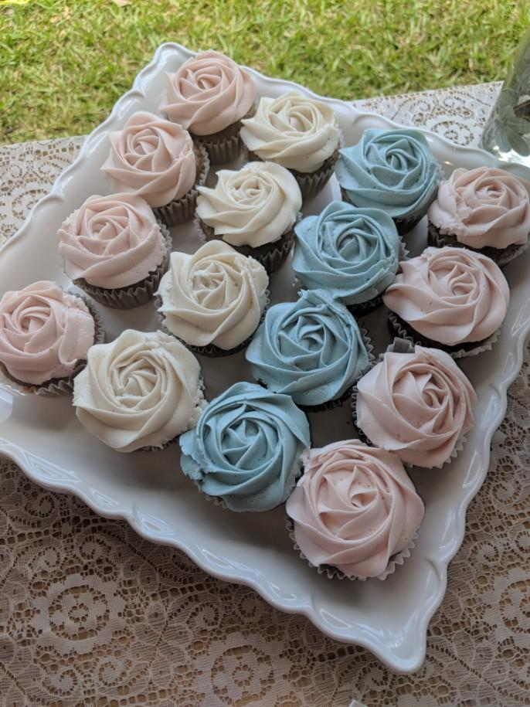
- 6 inch, 3 Layer, Round Cake with 12 matching cupcakes (buttercream icing, buttercream decorations, flower decorations included)
  - Upgrades available:
    - 8Inch add $15
    - 9 inch Add $25
    - 10 Inch Add $35
    - 12 inch Add $55
- Fresh Fruit Available- Add $ 15.00
    - Strawberry
    - Blueberry
    - Raspberry
- Full fondant wrap Starting at $30.00
    - 1-5 1-Dimensional Fondant Accents $20
    - 6-10 1-D Fondant Accents $35
    - 11 and up, 1-D Fondant Accents $50
    - 3D pieces starting at $45.00
- Delivery and setup $50.00 if under 20 miles away from bakery
    - Over 20 miles additional fee
The Second Tier Starting at $349.00
- Two tier cake 6 and 8-inch cakes round 18 matching cupcakes,
- Buttercream Icing, buttercream decorations
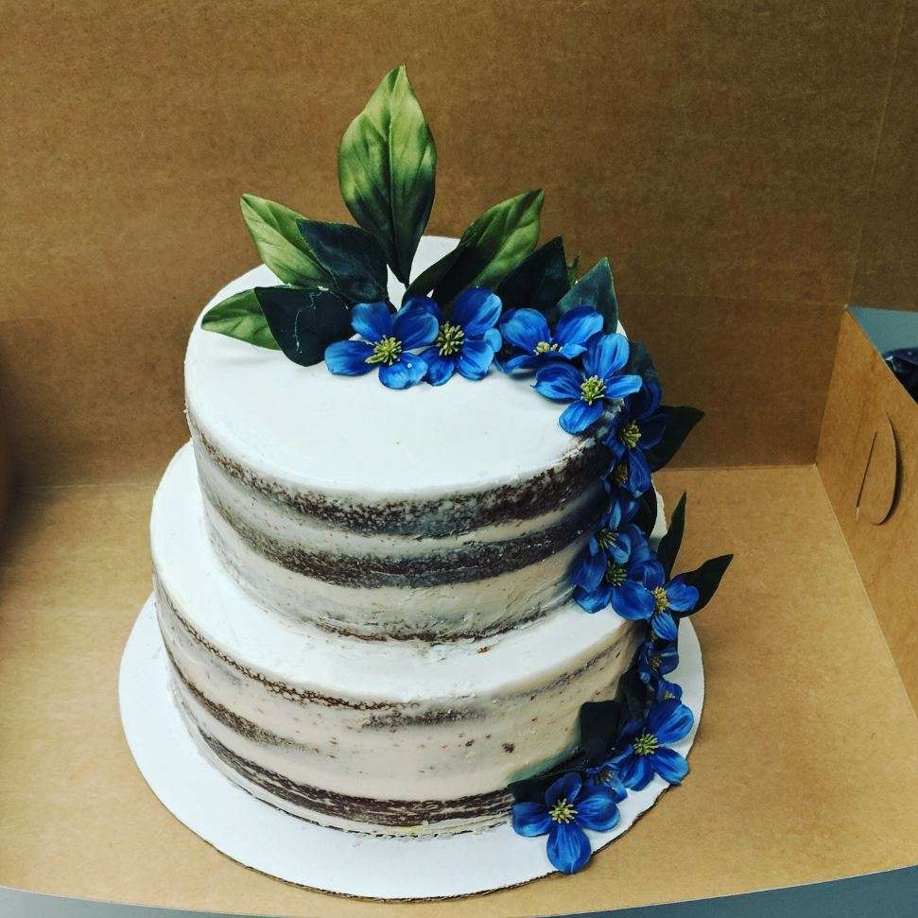
- Fresh Fruit Available Top Tier Cake Only- Add $20.00
    - Strawberry
    - Blueberry
    - Raspberry
- Larger Cake Sizes available for additional price
- Full fondant wrap starting at $30.00
    - 1-5 1-Dimensional Fondant Accents $20
    - 6-10 1-D Fondant Accents $35
    - 11 and up, 1-D Fondant Accents $50
    - 3D pieces starting at $45.00
- Delivery and setup $55.00 if under 20 miles away from bakery
    - Over 20 miles additional fee

The Third Tier Starting At $579.00
- Three Tier Cake, 6,8 and 10-inch cakes round with 24 Matching Cupcakes
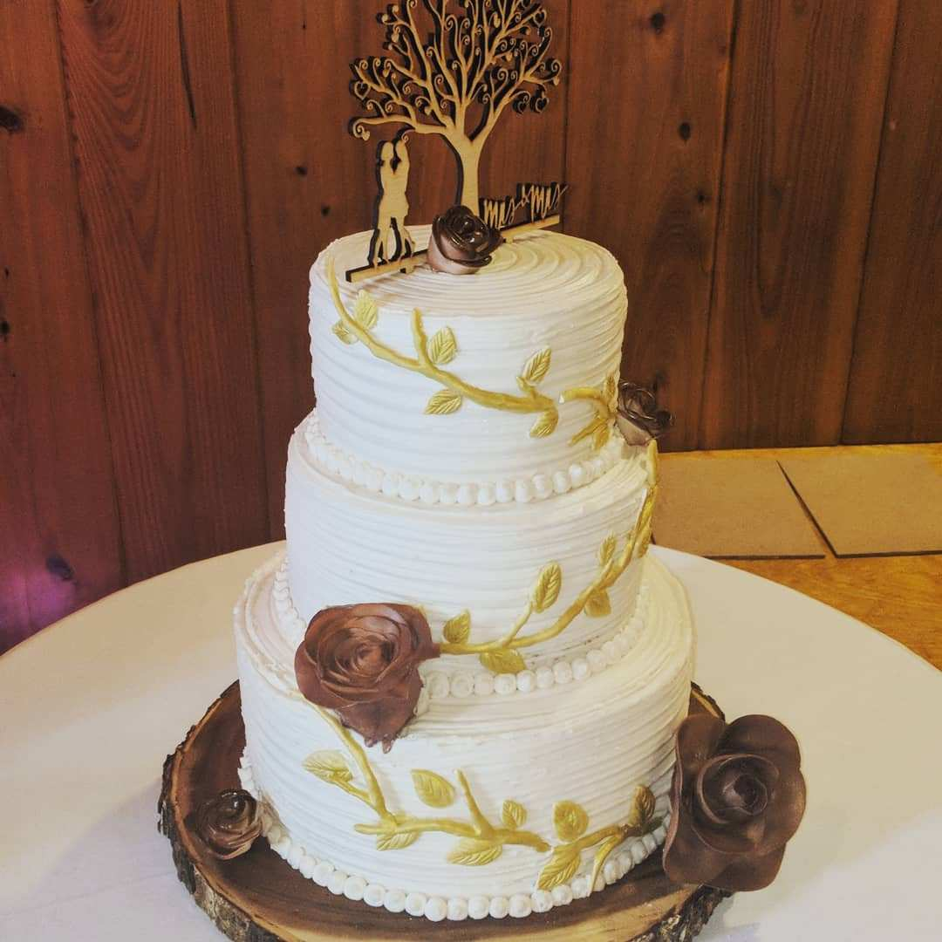
- Buttercream Icing, buttercream decorations
- Fresh Fruit Available Top Tier Cake Only- Add $20.00
    - Strawberry
    - Blueberry
    - Raspberry
- Larger Cake Sizes available for additional price
- Full fondant wrap starting at $30.00
    - 1-5 1-Dimensional Fondant Accents $20
    - 6-10 1-D Fondant Accents $35
    - 11 and up, 1-D Fondant Accents $50
    - 3D pieces starting at $45.00
- Delivery and setup $75.00 if under 20 miles away from bakery
Over 20 miles additional fee

The Fourth Tier Starting At $ 799.00
- Four Tier Cake, 6,8,10 & 12-inch round with 24 Matching Cupcakes
- Buttercream Icing, buttercream decorations
- Fresh Fruit Available Top Tier Cake Only- Add $20.00
    - Strawberry
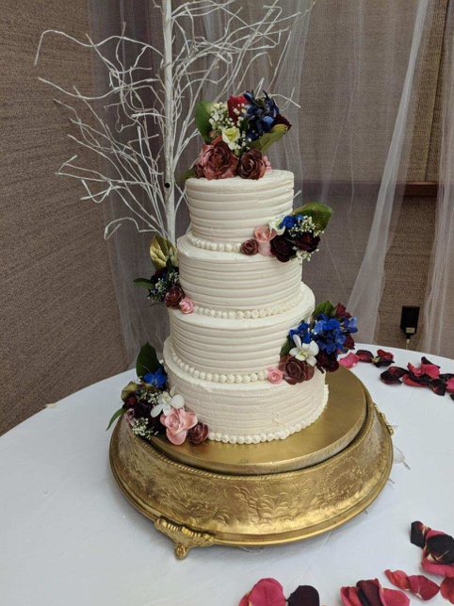
    - Blueberry
    - Raspberry
- Full fondant wrap starting at $30.00
    - 1-5 1-Dimensional Fondant Accents $20
    - 6-10 1-D Fondant Accents $35
    - 11 and up, 1-D Fondant Accents $50
    - 3D pieces starting at $45.00
- Delivery and setup $100.00 if under 20 miles away from bakery
Over 20 miles additional fee

The Royal Platinum Package Starts at $2400.00
- Five Tier Cake, 6/8/9/10/12-inch round cakes
- 50-piece assorted dessert bar / Bakers Choice
- All Tiers Fondant Covered / 10 pieces of 1 dimensional fondant accents per tier / 3 3d flowers per tier / 1 large 3d fondant piece for cake /
- Wedding Day Morning Delivery, The Happy Couple will each receive one of our specialty morning bakery boxes, 12 items per box, we will deliver this to each party at 10 am of the happy day (excludes Mondays or Holidays)
- Cake Delivery and set up free if under 20 miles
  - Over 20-mile delivery and setup fee of $250.00
- Wedding Party Cake Cuter Service, we will be at your wedding reception to assist in cutting cake slices for your guests (2-hour limit), we will securely wrap and box top tier for the couple to save, we will cut and box up to 50 slices for guest to take as Togo.
- To finish out the night we will provide the couple with a bottle of Dom Perion and 24 chocolate covered strawberries

*** ALL CAKES ARE STANDERD CIRCLE IN SHAPE****
**CAKE & CUPCAKE FLAVORS FOR THE PACKAGES ABOVE ARE: VANILLA, CHOCOATE & ALMOND

25% down payment due at booking / full payment required 7 days before wedding date
****************ALL Deposit non-refundable********************

Additional Add on available:
- Stand Rentals for Cakes and Cupcakes
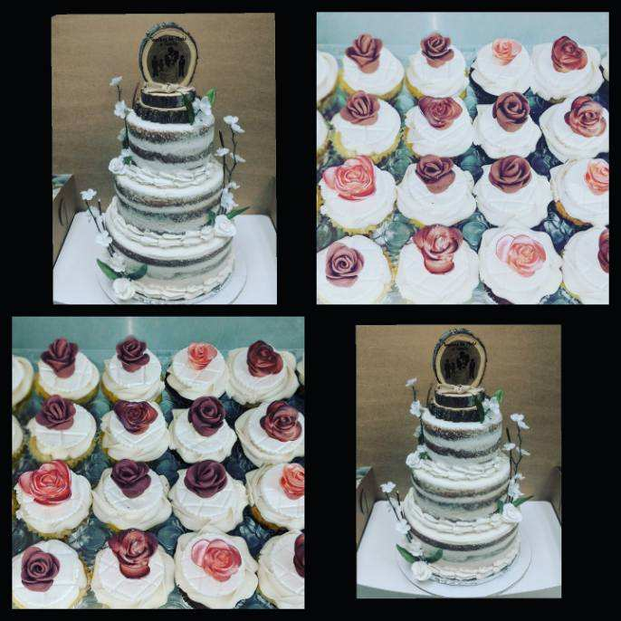
- Custom or Specialty cake/cupcake flavors
- Hand painting on cake
- Marbleizing fondant or glazed icing
- Custom Hand Piping
- Fondant Characters
- Cake Shapes available are:
  - Square
  - Heart
  - Hexagon
- Hand Carving

